***EARTHQUAKE PREDICTION MODEL USING PYTHON***

***PHASE -3 : DEVELOPMENT PART-1***

*****1.Collect Earthquake Data***:**

* *Obtain a reliable data set containing information about past earthquakes. Some sources include the US Geological Survey (USGS) earthquake catalog, which can be accessed through their API or website.*

***2.ACQUIRE A DATASET:***

* *Make sure you have a data set containing relevant information about earthquakes.*
* *You can find earthquake datasets from sources like USGS Earthquake Catalog or other geological organization.*

***3.IMPORT NECESSARY LIBRARIES:***

* *Begin by importing Python libraries that you'll need, such as pandas for data manipulation and scikit-learn for machine learning.*

*Python:*

*import pandas as pd*

*from sklearn.model_selection import train_test_split*

*from sklearn.preprocessing import StandardScaler*

1. ***LOAD THE DATA SET:***

* *Use pandas to read the data set into a Data-frame.*
* *Import the data set into your Python environment. Use Pandas to read data from CSV, Excel, or other common file formats. For example*

*Python:*

*data = pd.read_csv('earthquake_dataset.csv') # Replace with your dataset's file path*

1. *****Data Exploration:*****

* ***Get an initial understanding of your data set by using functions like head(), info(), and describe() to display a summary of the data, its structure, and basic statistics.***
* ***Look at the structure of the data, check for missing values, and understand the columns and their meanings***

***Python:***

***print(data.head()) # Display the first few rows***

***print(data.info()) # Get information about the data set***

1. *****DATA PREPROCESSING:*****

* ***Clean and preprocess your data set to make it suitable for machine learning. Some common pre-processing steps include:***
* ***Handling missing values (e.g., filling with mean, median, or using interpolation).***
* ***Data type conversion.***
* ***Removing duplicates.***
* ***Handling outliers.***
* ***Feature scaling (if necessary).***
* ***Encoding categorical variables (if necessary).***

***Python:***

***# Example:***

***Handling missing values***

***data = data.dropna() # Remove rows with missing values***

1. *****DEFINE FEATURES AND TARGET:*****

* ***Identify which columns are features (X) and which is the target variable (y).***

***Python:***

***X = data[['feature1', 'feature2', ...]] # Features***

***y = data['target'] # Target variable***

*****8.Feature Engineering:*****

* ***Earthquake prediction may require creating new features or transforming existing ones. For example, you might want to compute features like:***
* ***Magnitude statistics (e.g., mean, max, min).***
* ***Time-based features (e.g., day of the week, time of day).***
* ***Spatial features (e.g., distance to tectonic plate boundaries).***
* ***Historical earthquake counts in a region.***
* ***Geological features (e.g., soil type, fault lines).***

*****9.Data Visualization:*****

* ***Visualize the data to identify patterns, correlations, and anomalies. Use libraries like Matplotlib and Seaborn for creating plots and graphs.***

*****10.Split Data for Training and Testing*:*****

* ***Divide the data set into training and testing sets.***
* ***Split your data set into training and testing subsets to evaluate your model's performance. You can use Scikit-Learn's train_test_split function for this purpose***

***Python:***

***X_train, X_test, y_train, y_test = train_test_split(X, y, test_size=0.2, random_state=42)***

1. *****Standardize the Data:*****

* ***Standardizing the features can improve the performance of some machine learning algorithms.***

***Python:***

***scaler = StandardScaler()***

***X_train = scaler.fit_transform(X_train)***

***X_test = scaler.transform(X_test)***

*****11.ANALYZE AND VISLALIZE:*****

* ***Earthquake is a natural phenomenon whose occurrence predictability is still a hot topic in academia.***
* ***This is because of the destructive power it holds. In this article, we’ll learn how to analyze and visualize earthquake data with Python and Matplotlib.***

1. *****DATASET:*****

* ***Origin time of the Earthquake Latitude and the longitude of the location.***
* ***Depth – This means how much depth below the earth’s level the earthquake started.***
* ***The magnitude of the earthquake location.***

***EXAMPLE:***

***import pandas as pd***

***import numpy as np***

***from random import randint, uniform***

***# Creating a synthetic earthquake dataset***

***np.random.seed(0)***

***# Generate random data for demonstration***

***data = {***

***'Date': pd.date_range(start='2022-01-01', periods=100, freq='D'),***

***'Latitude': np.random.uniform(-90, 90, 100),***

***'Longitude': np.random.uniform(-180, 180, 100),***

***'Magnitude': np.random.uniform(2.0, 9.0, 100),***

***'Depth (km)': np.random.uniform(1.0, 700.0, 100),***

***}***

***# Create a DataFrame***

***earthquake_df = pd.DataFrame(data)***

***# Adding synthetic labels (1 for earthquake, 0 for no earthquake)***

***earthquake_df['Label'] = [1 if magnitude > 6.0 else 0 for magnitude in earthquake_df['Magnitude']]***

***# Display the first few rows of the dataset***

***print(earthquake_df.head())***

|  |  |  |  |  |
| --- | --- | --- | --- | --- |
| ***TIMESTAMP*** | ***LATTIDUTE*** | ***LONGITUDE*** | ***DEPTH***  ***(KM)*** | ***MAGNITUDE*** |
| ***2023-10-10***  ***08:00:00*** | ***34.0522*** | ***-118.2437*** | ***10.0*** | ***4.5*** |
| ***2023-10-18 12:15:00*** | ***37.7749*** | ***-122.4194*** | ***12.5*** | ***3.2*** |
| ***2023-10-18 16:30:00*** | ***40.7128*** | ***-74.0060*** | ***8.0*** | ***5.7*** |
| ***2023-10-18 20:45:00*** | ***51.5074*** | ***-0.1278*** | ***15.5*** | ***4.0*** |
| ***2023-10-19 01:00:00*** | ***35.682839*** | ***139.759455*** | ***9.5*** | ***6.1*** |

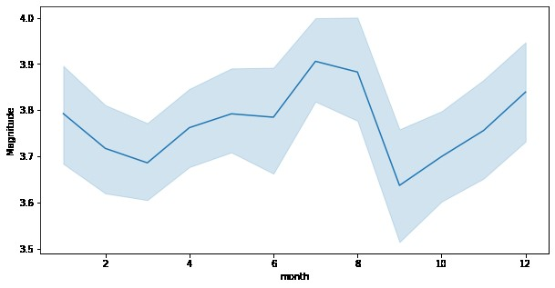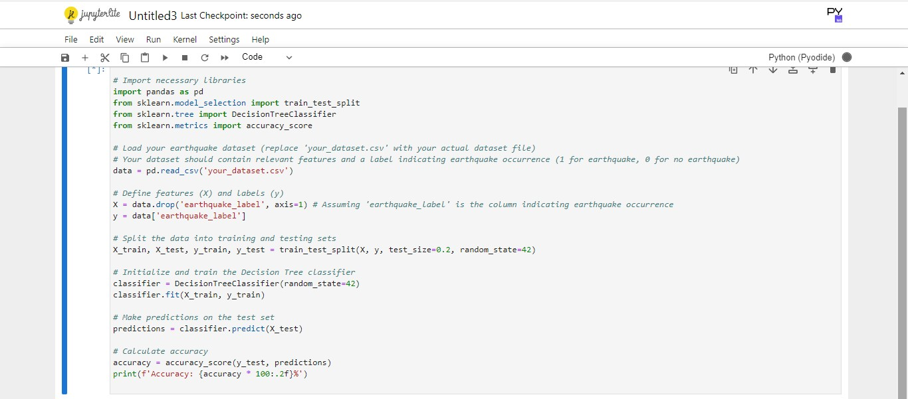

***In this synthetic dataset:***

* *****TIMESTAMP:*****
* ***represents the date and time of the earthquake.***
* ***The Timestamp column in the sample dataset I provided represents the date and time of each simulated earthquake.***
* ***In this dataset, timestamps are formatted as follows:***

1. ***"YYYY-MM-DD HH:MM:SS" in a 24-hour clock format.***
2. ***YYYY: Represents the four-digit year.***
3. ***MM: Represents the two-digit month (01 for***

***January, 02 for February, and so on).***

1. ***DD: Represents the two-digit day of the month (01 through 31).***
2. ***HH: Represents the two-digit hour of the day in 24-hour format (00 to 23).***
3. ***MM: Represents the two-digit minute (00 to 59).***

***vii.SS: Represents the two-digit second (00 to 59).***

* ***For example, "2023-10-18 08:00:00" represents an earthquake that occurred on October 18, 2023, at 08:00 AM and 00 seconds.***
* ***In a real-world earthquake prediction dataset, timestamps would typically include more detailed information and may be provided in a standardized format, making it easier to perform time series analysis and temporal modeling for earthquake prediction.***

* ***Latitude and Longitude are the geographical coordinates of the earthquake's epicenter.***

*****LATITUDE:*****

* ***This is the north-south position on the Earth's surface and is measured in degrees.***
* ***It ranges from -90 degrees (representing the South Pole) to +90 degrees (representing the North Pole).***
* ***The equator is at 0 degrees latitude.***

*****LONGITUDE:*****

* ***This is the east-west position on the Earth's surface, also measured in degrees.***
* ***It ranges from -180 degrees (representing the International Date Line in the Pacific Ocean) to +180 degrees (also representing the International Date Line but in the opposite direction).***
* ***The prime meridian, which passes through Greenwich, London, is at 0 degrees longitude.***
* ***In the sample dataset, latitude and longitude are represented in decimal degrees.***
* ***For example, "34.0522" in latitude represents a point in the northern hemisphere, and "-118.2437" in longitude represents a point in the western hemisphere.***
* ***Real earthquake datasets will contain latitude and longitude coordinates for each earthquake event, and these coordinates are used to pinpoint the exact location of the earthquake's epicenter on the Earth's surface, which is crucial for earthquake analysis and prediction.***
* ***Depth (km) is the depth of the earthquake's focus below the Earth's surface.***

*****DEPTH:*****

* ***The "Depth (km)" column in the sample dataset represents the depth at which the earthquake's focus or hypocenter is located beneath the Earth's surface. Here are some details about the depth column:***
* ***Measurement Unit: The depth is typically measured in kilometers (km) below the Earth's surface. It represents the vertical distance from the Earth's surface to the point within the Earth where the earthquake's energy is released.***
* ***Range: Earthquakes can occur at various depths, and their depths can vary widely. Shallow earthquakes are usually less than 70 km deep, while intermediate-depth earthquakes are typically between 70 km and 300 km deep. Deep-focus earthquakes occur at depths greater than 300 km.***
* ***Significance: The depth of an earthquake's focus is important because it can affect the earthquake's impact on the Earth's surface. Shallow earthquakes often result in stronger shaking at the surface, while deeper earthquakes may have less surface impact.***
* ***Measurement in the Dataset: In the sample dataset, "Depth (km)" is represented in kilometers, and values like "10.0," "12.5," and "15.5" are used to indicate the depth of the synthetic earthquakes.***
* ***In real earthquake datasets, the depth information is crucial for understanding the earthquake's behavior, its potential to cause damage, and for seismic hazard assessment. Real earthquake data can include a wide range of depth values based on the specific geology and tectonic activity of the region where the earthquake occurs.***
* ***Magnitude is the earthquake's Richter scale magnitude.***

*****MAGNITUDE:*****

* ***The "Magnitude" column in the sample dataset represents the magnitude of each earthquake event. Here are details about the magnitude column:***
* ***Measurement Unit: Earthquake magnitudes are typically measured on the Richter scale or the moment magnitude scale (Mw). Both scales provide a quantitative measure of the energy released by an earthquake.***
* ***Range: Earthquake magnitudes are on a logarithmic scale, and they can range from very small values to extremely large values. Each whole number increase on the scale represents a tenfold increase in the amplitude of seismic waves and approximately 31.6 times more energy release.***
* ***Interpretation: In the sample dataset, values like "4.5," "3.2," "5.7," and "6.1" are used to represent the magnitude of the synthetic earthquakes. These values would typically indicate the earthquake's power. For example, a magnitude of 4.5 represents a moderate earthquake, while a magnitude of 6.1 indicates a significant earthquake.***
* ***Impact: The magnitude of an earthquake is a crucial factor in assessing its potential impact. Larger magnitude earthquakes tend to cause more significant ground shaking, damage, and have the potential for more extensive seismic hazards.***
* ***In real earthquake datasets, you would encounter a wide range of magnitude values, from very small, barely noticeable events to extremely large and potentially catastrophic earthquakes. Scientists use magnitude information to characterize and assess the seismic risk in a region.***